|  |  |  |  |
| --- | --- | --- | --- |
|  | **Digital Business Card Apps: A Comprehensive Report** | |  |
|  | |
| 19/12/2023 | |
|  |  | |  |
| Veer Patel (Data Science Intern) |  |  |
|  | |  |

**Executive Summary**

Digital business cards are rapidly replacing their paper counterparts, offering a more sustainable, convenient, and interactive way to share contact information. This report explores the growing market of digital business card apps, highlighting their features, benefits, and considerations for businesses and individuals.

**Market Overview**

According to a new report published by Allied Market Research, titled, “[Digital Business Card Market](https://www.alliedmarketresearch.com/digital-business-card-market)," The digital business card market was valued at $159.36 million in 2022, and is estimated to reach $505.2 million by 2032, growing at a CAGR of 12.6% from 2023 to 2032.

**Introduction**

Digital business cards represent the evolution of traditional business cards into digital realm, providing professionals with modern and efficient ways to exchange contact information and promote their businesses in a digital and interconnected world. In addition, digital business cards are created and shared electronically, allowing professionals to exchange contact information quickly and conveniently. These digital cards can be stored on smartphones, tablets, or other digital devices and can be easily shared via email, text messages, QR codes, or through various mobile apps and platforms.

**Key Features of Digital Business Card Apps**

* Create and customize cards: Most apps offer a variety of templates and design tools to create professional-looking cards. You can add your logo, photo, contact information, social media links, and more.
* Share and connect: Cards can be shared easily via QR code, NFC, email, text message, or social media. Some apps even allow you to track how your cards are being viewed and interacted with.
* Integrations: Many apps integrate with popular CRM and email platforms, making it easier to manage your contacts and follow up with potential leads.
* Additional features: Some apps offer advanced features like analytics, lead generation tools, virtual backgrounds, and even video introductions.

## **The Best Digital Business Card Makers**

### **1. Popl**

A leading digital business card creator, [Popl](https://popl.co/) helps individuals and teams make beautiful digital business cards that can be shared in multiple ways.

The company offers many NFC products to make digital card sharing easier. You can get a card, wristband, badge, and other options.

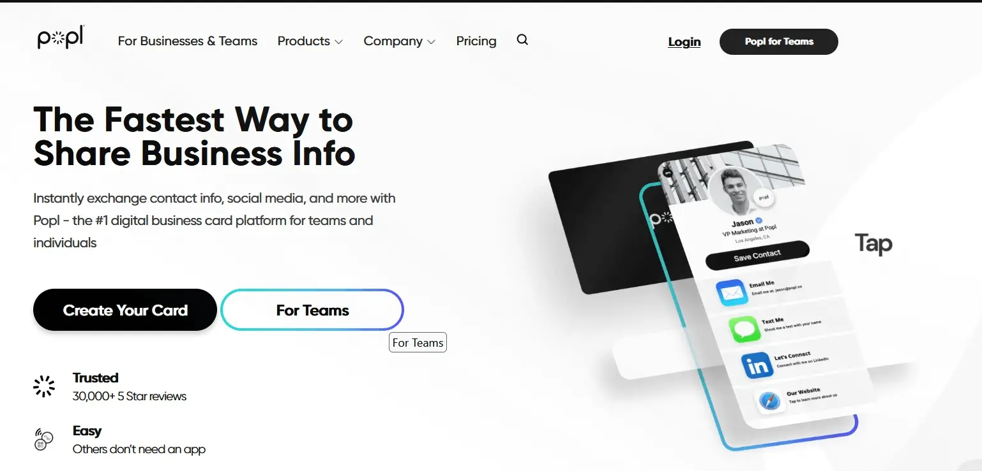

**Key Features:**

* You can instantly share information (contact info, social media accounts, payment apps, videos, and files) by tapping, scanning, or sending.
* Popl enables you to capture leads from your profile. Then, you can favorite, group, sort, and manage all those leads in Popl itself.
* You can easily export captured leads to your favorite CRM. Popl can be directly integrated with Zoho, Salesforce, Hubspot, and many other CRMs.
* Popl solutions can help you grow faster by allowing you to easily make more connections, capture more leads, and generate more sales.

Popl offers 24/7 one-on-one customer support to help business owners design perfect digital business cards.

**Pros:**

* Popl offers mobile business cards with excellent NFC capabilities.
* The company also allows you to have both physical business cards and digital business cards.
* You can easily update information on your digital business cards.

**Cons:**

* Popl offers various digital business card solutions with many advanced features. But these features come at a cost. So you should be ready to buy a subscription plan to use advanced features.

**Pricing:**

Popl offers a free plan that allows you to create one free digital business card. Its paid plans start from $6.49 per month, billed annually.

Popl also offers a 14-day free trial to try its various paid plans.

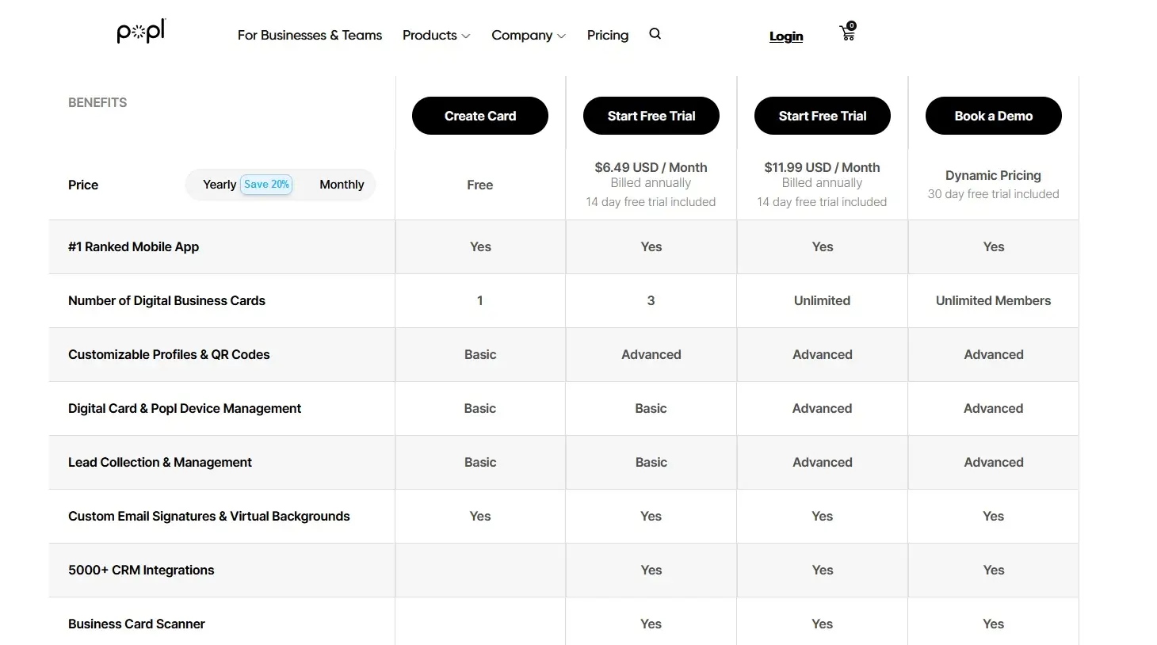

### **2. Blinq**

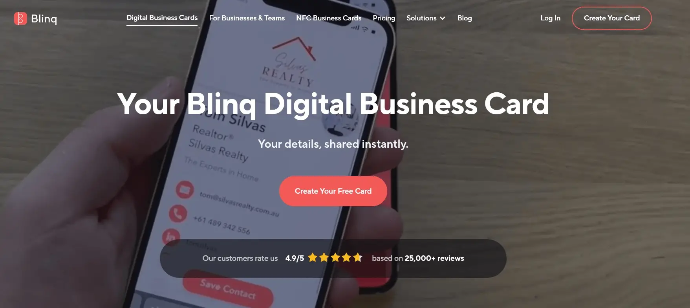

If you want to leave a lasting impression on people you meet in a networking event, sharing a Blinq electronic business card can do the trick.

Used by leading companies such as Google and Uber, Blinq digital business cards are easy-to-create. And you will have multiple ways to share your digital business card.

From the Apple Watch app to smartphone widgets to NFC cards, you have various ways to let people grab your contact details and other related information.

**Key Features:**

* There is no need to take your phone out of your pocket to share your digital visiting card. You can share your card right from your Apple Watch.
* You can easily customize your business card with your company logo and color scheme to maximize the success of your marketing efforts.
* You can add your business card to the virtual background of Zoom and MS Teams.
* Blinq focuses on the privacy and security of its client’s data. So you will have secure sharing of contact information and other related details.

**Pros:**

* There is no cap on card sharing. So you can share an unlimited number of cards to grow your network.
* It comes Apple Watch app to share QR codes with prospective customers.
* You can add notes to your contacts’ cards to make them more memorable.
* You can create dynamic email signatures.

**Cons:**

* Blinq doesn’t have the option to print paper business cards with dynamic QR codes on them. But you can download Blinq dynamic QR code and print it on a paper card with a provider of your choice.
* You may feel Blinq lacks color customization options.
* You cannot add videos to your business cards.

**Pricing:**

* Blinq plan for business starts from $5.99 per card per month (three card minimum). All plans come with a 30-Day free trial. For individuals, Blinq also offers a free plan.

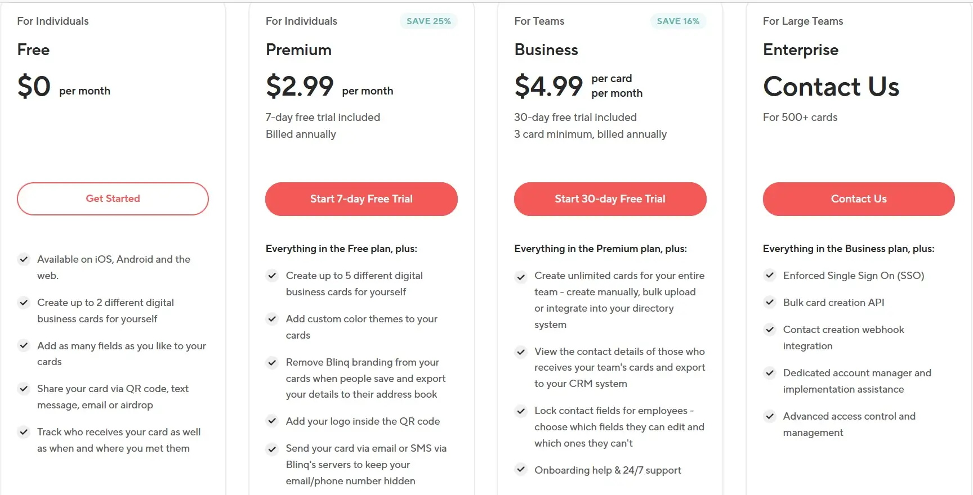

### **3. Beaconstac**

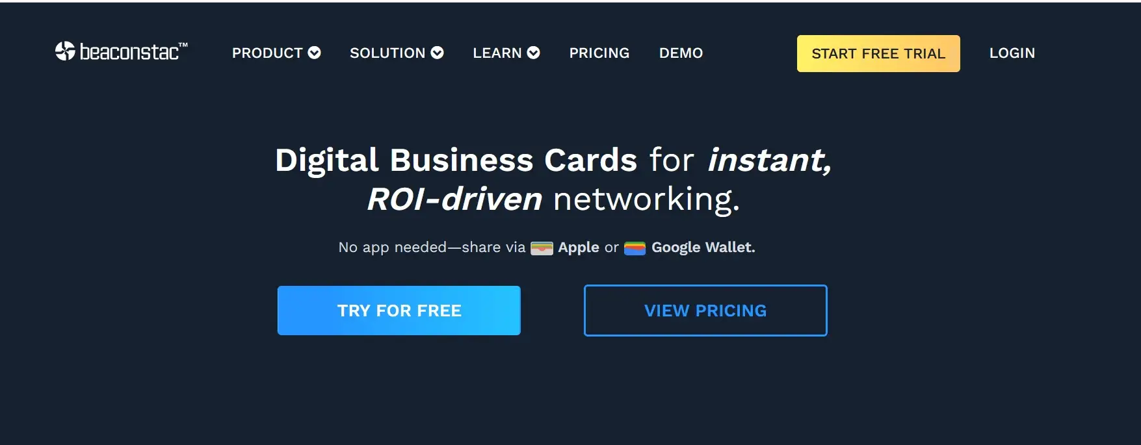

If you are looking for digital business cards with easy QR code functionality, Beaconstac is the right company for you. And the best part is you don’t need an app to share Beaconstac digital business cards. You can share these cards via Apple or Google Wallet.

**Key Features:**

* The company emphasizes the security of its clients. Its solutions are SOC-2 Type 2 & GDPR compliant and support multi-factor authentication.
* You can centrally manage your cards as an admin and enforce brand templates.
* You can integrate it with your favorite CRM software. Beaconstac’s digital business cards can be integrated with 5000+ CRMs and HR tools.
* Beaconstac business cards allow you to track how often your prospects have checked out your business cards.

**Pros:**

* The bulk creation feature enables you to create digital business cards in bulk in just two clicks.
* The company offers world-class customer support to its clients. So you will not have difficulty creating powerful business cards to make an excellent first impression on your prospects.
* You can easily update your company information with the help of dynamic QR codes. And you can easily add custom colors, logos, backgrounds, and more to your digital business cards’ QR code.
* You can get a custom domain for higher plans.

**Cons:**

* The starting plan doesn’t support the bulk creation feature and many other useful features.
* Some small businesses can find it expensive.

Subscription plans start from $6 per user per month. You can contact the company for custom pricing if you are running an enterprise. Beaconstac offers a 14-day free trial.

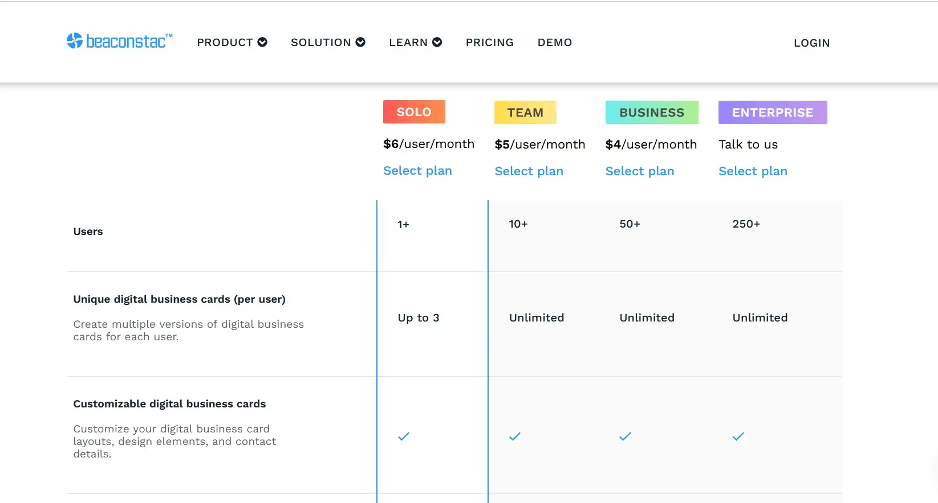

**4. V1CE**

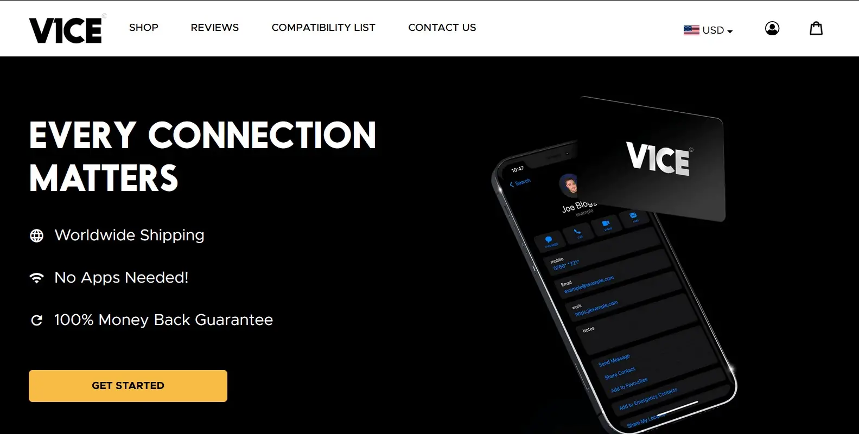

V1CE is known to offer classy digital business cards. The company offers NFC-enabled cards with worldwide shipping. Moreover, you can order an iPhone NFC smart case with a message. This digital business card solution puts the power of a business card in the convenience of your phone.

**Key Features:**

* The best thing about V1CE cards is you don’t have to buy any subscription or use an app to start using a V1CE digital business card.
* You can choose a base material of your choice for your NFC card. The company currently makes physical cards in metal, bamboo, or plastic.
* You can get the help of inhouse-designers of the company to design your NFC cards.
* You can easily add, edit, and delete the information in your profile to share updated information on your NFC card.

**Pros**

* V1CE offers stylish digital business cards that allow business owners to change their contact details in just a few clicks.
* You don’t have to pay any monthly fee to use a V1CE digital business card.
* NFC cards will also have a QR code printed on the back, allowing people with older phones that don’t support NFC to capture your contact details.

**Cons:**

* As the company offers physical cards, there is no free option. So you have to spend money even to try the V1CE product.
* Sometimes, the product you want to buy might not be available.

**Pricing:**

V1CE offers NFC cards made of plastic, metal, and bamboo. So the price can vary, depending on the type of material your pick for your digital business card. Black PVC One card costs $70 (without discount). And the price of the Android NFC case is $51, while the iPhone NFC case costs $70.

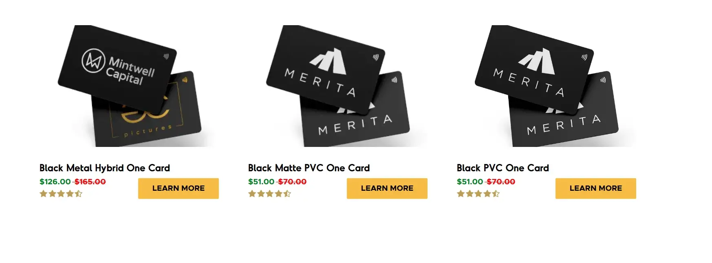

### **5. HiHello**

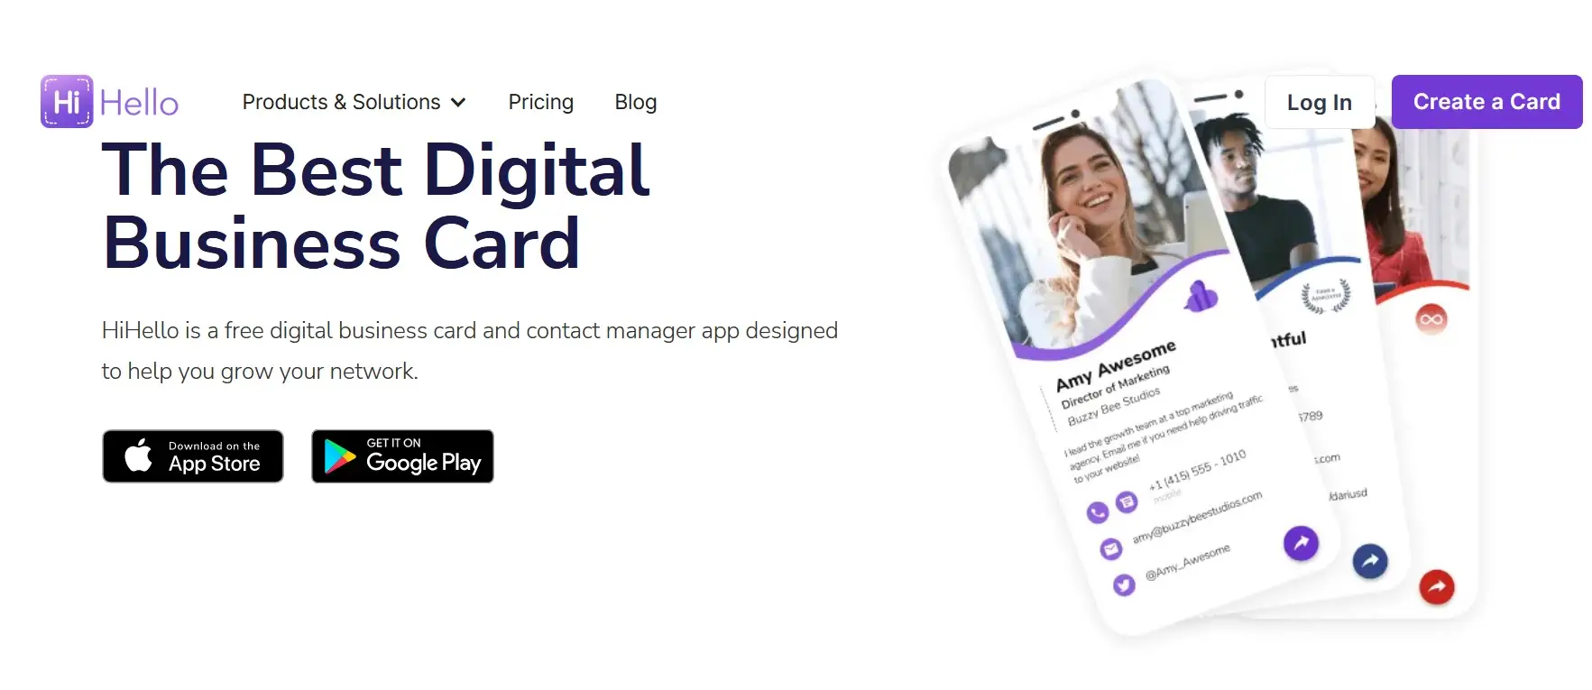

If you have just started your business and don’t have money to spend on marketing and networking, HiHello digital business card is your best bet. HiHello free app is available on Android and iOS devices.

**Key Features:**

* You can share your HiHello digital business card with your prospects in multiple ways, including QR code, Link sharing, Airdrop, NFC tag, Apple Watch, and many more.
* The business card scanner feature enables you to scan physical business cards and have the contact details added to your address book. And the best thing is human verification is done when you scan physical business cards to ensure you have the correct information.
* You can share your virtual business card by displaying a QR code on a virtual background during an e-meeting on Zoom, Teams, or Google Meet.
* Its professional email signature generator helps you create a professional-looking email signature that links to your digital business card.

**Pros:**

* HiHello offers an easy-to-navigate dashboard to create and update digital business cards.
* You can include your photo, live photo or video, social media accounts, company logo, Yelp page, chat apps, and much more in your digital business card.
* HiHello app is the top-rated app on Google Play and App Store. So you can rest assured that you’re using a trusted app.
* You can easily convert an NFC tag into a digital business card with the help of the HiHello app.

**Cons:**

* It doesn’t offer a bulk digital business card creation feature.
* Some small business owners can find analytics too basic.

**Pricing:**  
A free plan allows you to create four digital business cards. For a business team of 5+ users, the pricing is $5 per user. And the Professional plan costs $6 per user.

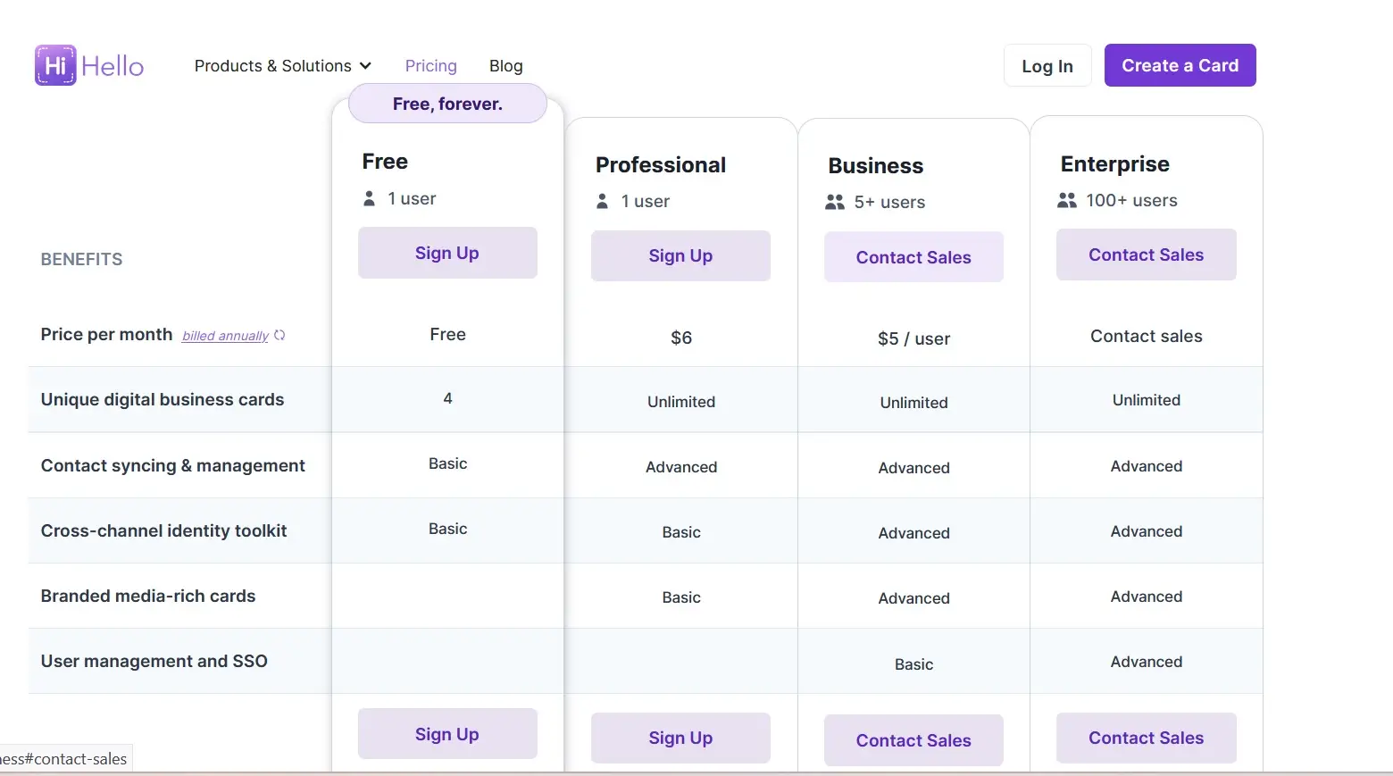

### **6.Haystack**

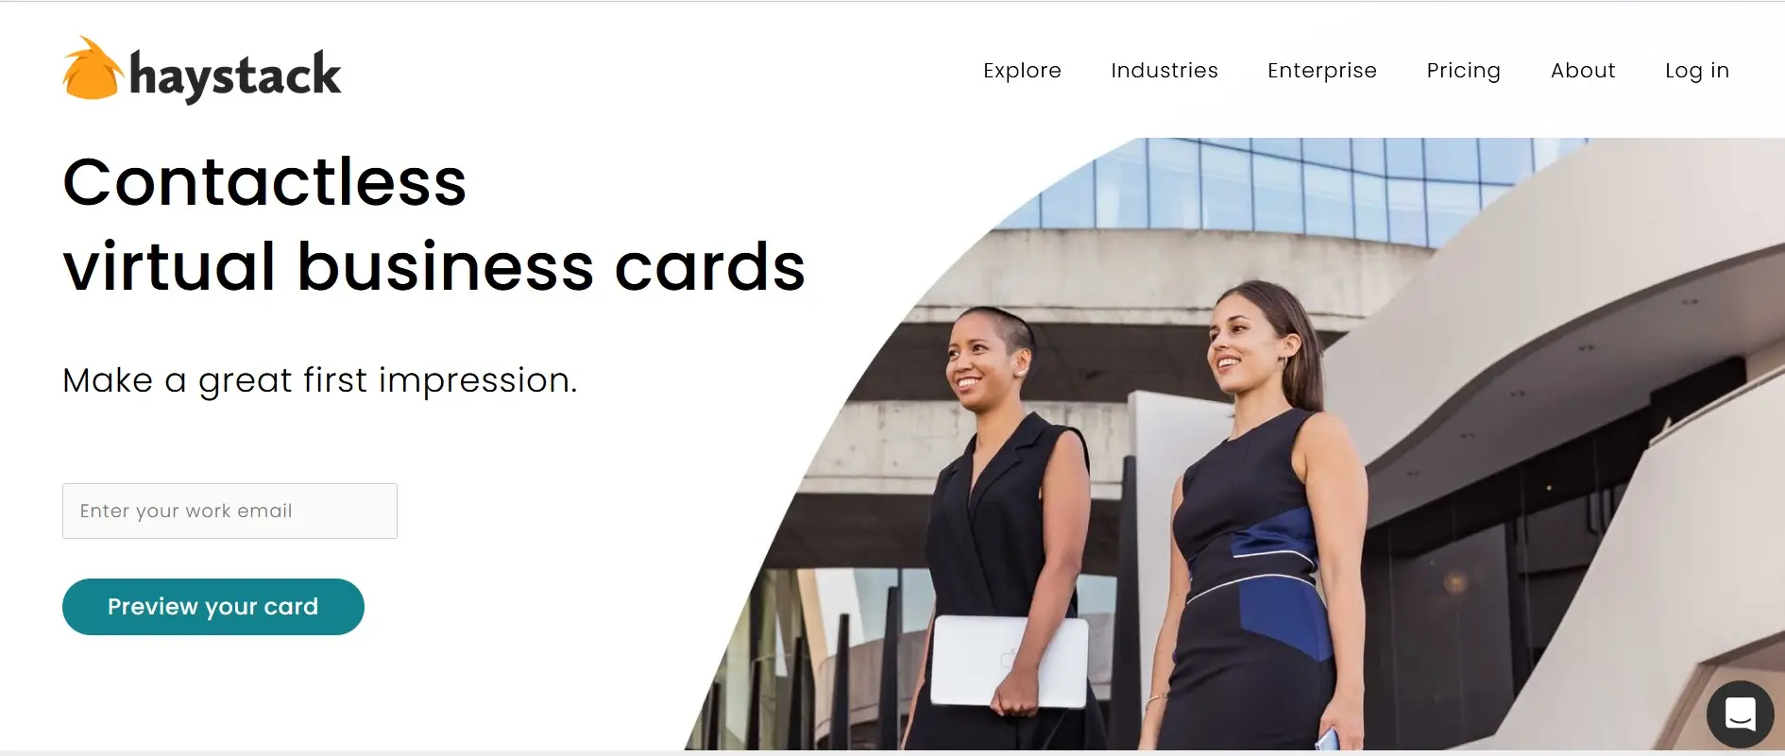

Haystack offers beautiful virtual business cards to make a great first impression. It is one of the world’s largest digital business card providers. With Haystack, you can drive traffic to your company website, social media, or other links.

**Key Features:**

* Your Haystack card will have a unique QR code and a Unique URL. So you can share your Haystack card easily with anyone.
* Once your prospects have saved your business card in their phones, your name will display when they call you. This means your number will not come up as an unknown number.
* Your Haystack digital business card lets you add an email signature to any email client.
* Haystack emphasizes privacy and security. So you don’t have to worry about data security.

**Pros:**

* A free plan allows you to create unlimited cards and save unlimited contacts.
* A paid plan enables you to create a vanity URL for your business card.
* You can integrate the Haystack card with all leading CRMs.
* Haystack offers you analytics to understand how effective your marketing efforts are.

**Cons:**

* There is no NFC option available presently.
* Only premium plans offer access to analytics.

**Pricing:**

The free plan of Haystack will meet your basic needs, and its business plan starts at $4,95 per month. For enterprise pricing, you can contact the company.

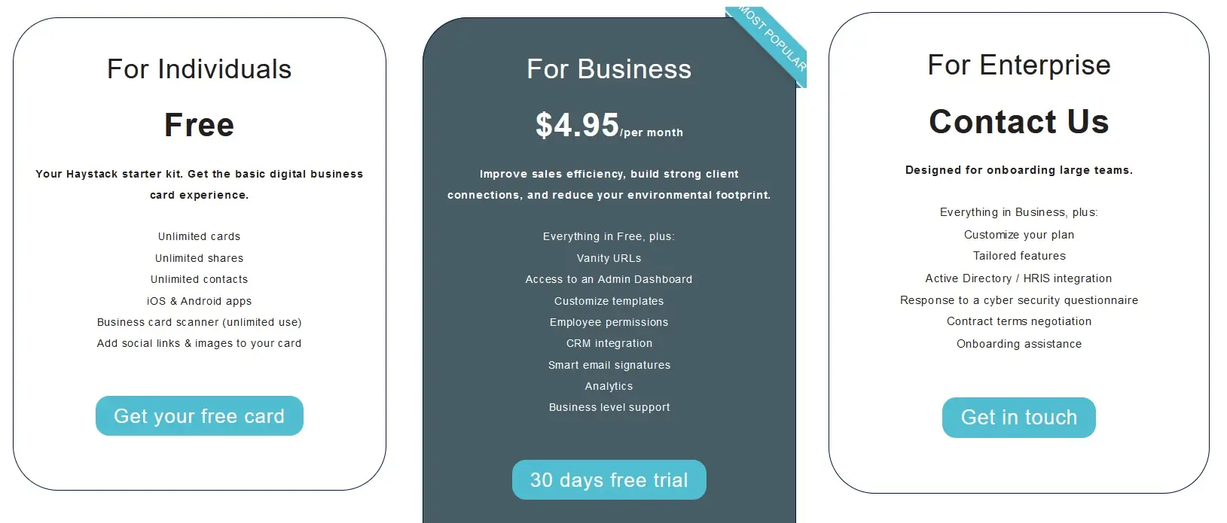

### **7. KADO Network**

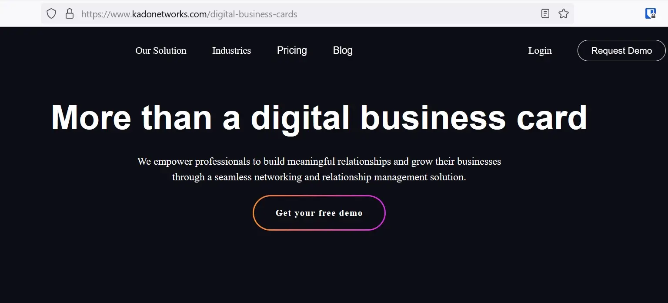

KADO, as it claims, is an all-in-one networking and relationship science tool. It allows you to share digital business cards, receive business cards, and organize cards. KADO can help you capture leads and centralize your contacts.

**Key Features:**

* With a KADO digital business card, you can edit colors to complement your branding.
* A KADO digital business card allows you to include the address of your office location, social media links, videos, and personalized buttons.
* KADO offers multiple options to share your digital business card. In addition to the mobile app, you can share your e-business card via QR code, widget, wallet, or email signature.
* KADO comes with an admin control feature that lets you fully control how your employees use their e-business cards. This feature will enable you to oversee analytics, privacy management, integration control, and more.

**Pros:**

* It is easy to navigate through its user-friendly interface. So it will reduce the time your team would otherwise spend managing your contacts.
* The best thing about KADO is you can sync all your contacts to one place.
* You can integrate KADO with 1000+ CRMs.
* vCard feature allows you to share your contact details with your prospects even when your Internet is not working.

**Cons:**

* A free plan lacks advanced features like personalized buttons, call-to-action, customized privacy settings, etc.
* Some small businesses may find KADO business cards costlier than other solutions.

**Pricing:**

KADO has a free plan with limited features. Its paid plan starts from $4.95 per month. The company also offers a free trial.

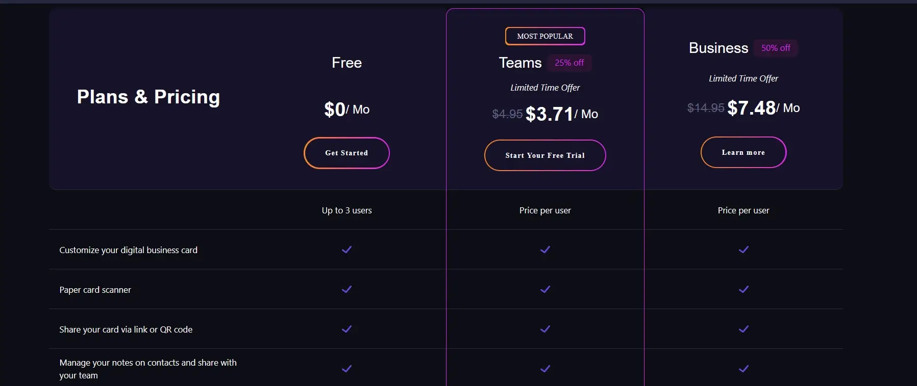

### **8.Linq**

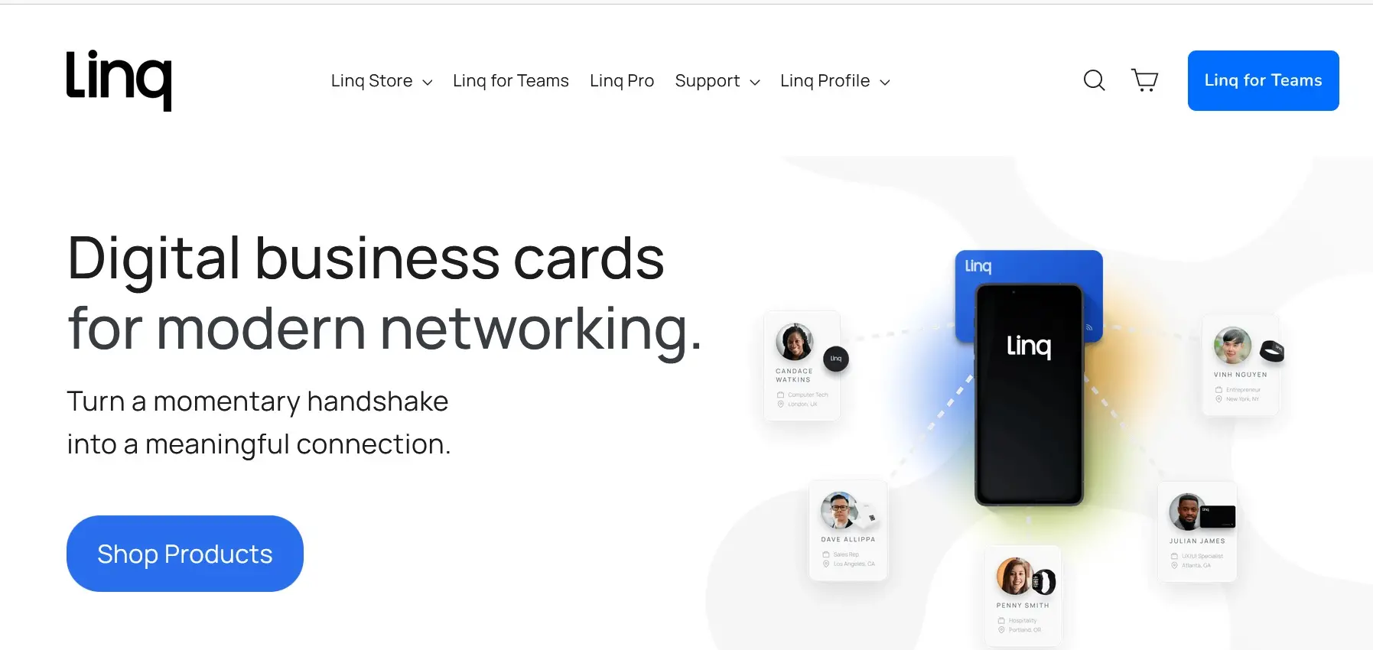

If you are a networking professional, [Linq](https://buy.linqapp.com/) can be an ideal digital business card for you. Linq allows you to share information with prospects using a customizable page.

**Key Features:**

* You can create multiple profiles for different settings under one account.
* You can set up reminders to follow up with new contacts. This feature will help you convert leads into customers.
* You can fully customize your digital business card to leave a lasting impression on your prospects.
* You can attach one or more profiles to multiple products.
* With LinqPro, you can embed videos into your card.

**Pros**

* Linq offers a wide range of products to choose from, including tags, custom cards, badges, bracelets, and product bundles for networking and events.
* You can integrate Linq with 380+ CRMs.
* Linq offers real-time analytics to gauge the success of your networking efforts.
* It offers flexible subscription plans for teams.

**Cons:**

* Some users may find Linq virtual business card app is not as intuitive as other solutions are.
* You have to pay a monthly fee to use advanced features, such as embedding videos, music, forms, calendar integration, etc.

**Pricing**

The price of a Linq product depends on the solution you decide to buy. Linq card pricing starts from $11.99. The networking bundle costs $44.99.

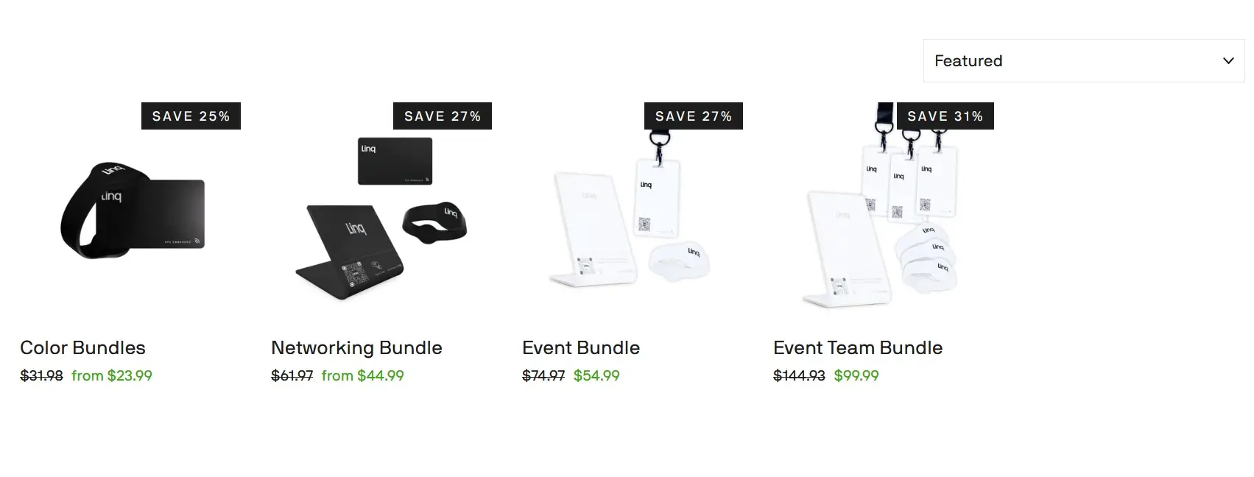

**Advantages of Digital E-Card**

Digital business e-cards offer a vast array of advantages over traditional paper cards, making them a more sustainable, convenient, and impactful networking tool. Here's a breakdown of some key benefits:

Environmental:

* Paperless: Eliminate the need for printing and paper waste, making your networking eco-friendly.
* Reusable: Update your information instantly within the card, instead of reprinting new batches like with paper cards.
* Durable: Digital cards won't get lost, crumpled, or faded, ensuring your contact information remains accessible and professional.

Convenience:

* Contactless Sharing: Share your card instantly via QR code, NFC, email, or text message, eliminating the need for physical exchange.
* Accessibility: Always have your business card with you on your phone, no matter where you are.
* Multiple Links: Easily link to your website, social media profiles, or any other relevant online platform.
* Automatic Updates: Update your contact information easily and instantly, without reprinting or replacing your card.

Efficiency and Analytics:

* Integration with CRM and Email: Seamlessly add new contacts to your existing systems for easy follow-up.
* Data Tracking: Gain valuable insights into how your card is being viewed and interacted with, allowing you to tailor your networking strategy.
* Lead Generation: Some apps offer built-in tools to capture leads and convert interactions into potential clients.
* Analytics: Track clicks, interactions, and downloads to measure the effectiveness of your digital handshake.

Professionalism and Branding:

* Design Freedom: Choose from a variety of templates or create custom designs that reflect your unique brand identity.
* Multimedia Content: Include videos, animations, or even virtual backgrounds to make your card stand out.
* Interactive Features: Add call-to-action buttons to encourage engagement and connect with potential clients directly.
* Modern and Innovative: Digital cards showcase your tech-savvy approach and impress potential partners.

Cost-Effectiveness:

* No Printing Costs: Eliminate the expense of printing, designing, and shipping paper business cards.
* Subscription-Based: Many apps offer affordable monthly or yearly plans, making them cost-effective for individuals and businesses.
* Scalability: Easily add team members or update your brand identity, all within the same platform.

Overall, digital business e-cards offer a plethora of advantages compared to traditional paper cards. They're more environmentally friendly, convenient, efficient, professional, and cost-effective, making them the perfect choice for anyone looking to build meaningful connections in the modern world.